Every year all taxpayers deem tax return preparation a heavy and perplexed ordeal that most of them pay a professional to do it for them. Choosing who to do it also needs some time to think, are they good? Are they trustworthy? What is their track record? Will they be able to deliver the output in a timely manner without missing anything in your books? There is a variety of tax preparation professionals, their expertise, training and experience, even some states have specific regulations about tax preparers.
Edmond Consulting Group LLC (ECG) is honored by our returning client base and welcomes new individual and business clients seeking our financial services. We give the same attention to all clients. The income tax, and other financial services we provide are tailored to the unique needs of each client, ensuring the best possible results and maximized “returns”. Our firm remains on the cutting edge of tax law and financial trends. We are well-informed and continually adapt to the ever-changing world of tax law and financial planning.

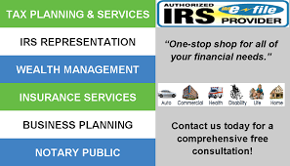
HM Community Advocates receive a discount priced. ASK HOW!!
Call ECG today at 404-803-0443.
Book you appointment thru our mobile app:
ecgllc.appsme.com

