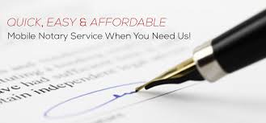

There are countless situations where you may need a notary. As a general notion, you should consider Edmond Consulting Group LLC whenever you have an official document that holds the potential for fraud and/or litigation. ECG notaries can help in the following situations:
- Administering oaths and affirmations
- Taking affidavits and depositions
- Certifying acknowledgment or proofs of deeds
- Verifying mortgages and powers of attorney (and other instruments in writing)
- Demanding acceptance or payment of foreign bills of exchange as well as promissory notes
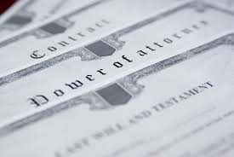
It is important to note that ECG is not empowered to marry couples. Also, notarizing a will does not give the will satisfactory legal force, and ECG notaries cannot, by law, certify “true copies” of documents.
We will travel to your home or business for your convenience to notarize any legal documents so you don’t have to take time off from work. ECG provide notary services conducted in your home or office, days, evenings and weekends.
Call Erica T Edmond, MBA at (803) 716-9901 Today

