EDMOND CONSULTING GROUP LLC
“Your one stop advisory firm.”
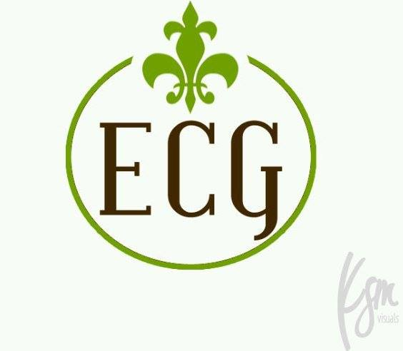
Facebook: @ericatedmond
HM Facebook: @ HealthMarkets.EricaEdmond
LinkedIN: ecgllc
Website: www.consultwithedmond.com
Mobile App: ecgllc.appsme.com
Office: (404) 803-0443

Health-Life-Medicare-Home-Auto-Business-Commerical-Property Adjusting-Tax Service- Mobile Notary

CALL TODAY!

